Seminole Middle School * April 2016 * Vol 3

SMS News
Seminole Middle School Newspaper
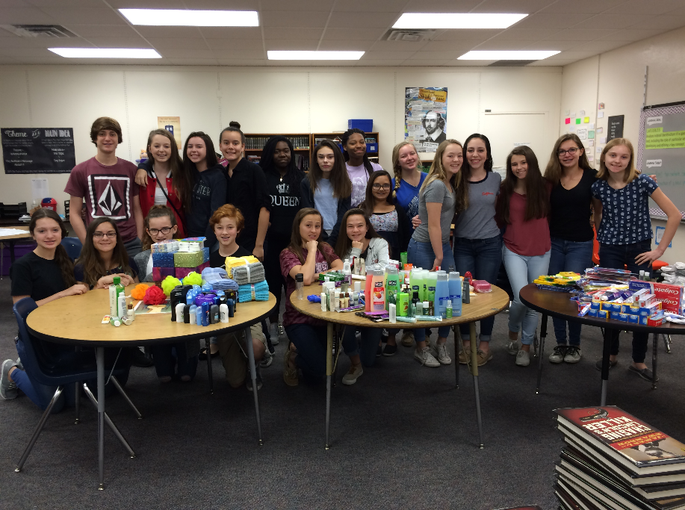
____________________________________________________________
NJHS Service Project
Students of Seminole
By: Sydney Biehle

What is your biggest fear?
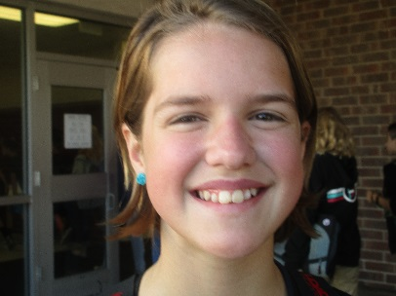
Davia Schweitzer– 6th Grade
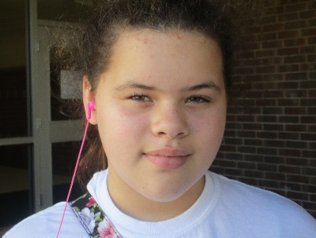
“My biggest fear is losing my family.”
Elle Rhodes – 6th Grade
”My biggest fear is my imagination.”

Inside this issue
Book Review pg 2
Fashion pg 2
Teacher Feature pg 2
Literary Corner pg 3
Theater Review pg 3
Seminole Events pg 3
Teen Heroe pg 4
Game Review pg 4
Restaurant Review pg 4
Word Scramble pg 4
Around the World pg 5
Photo of the month pg 5

Students arrived early to sort and box the items collected for teens in need.

National Junior Honor Society Service Project
BY: SMS Staff Writer
The NJHS recently completed their service project of collecting helpful items for the teen homeless shelter. Mrs. Marn, offers a big thank you to everyone who assisted NJHS by donating. According to Mrs. Marn, they were able to collect a lot of helpful items.

Around the world

The real cost of clothing
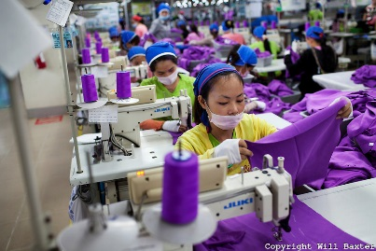
By Cyrus Karagan
long work days in hazardous conditions
Cambodia garment workers withdraw following their confrontation
Continued on page 5

SMS News

Book Review
By: Ariel Pearson

I give this book a 5 out of 5
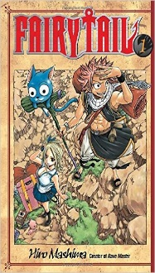
Fairy Tail Book 1
Hiro Mashima

Appeals to anime fans

Lucy, a young celestial wizard, runs away from home and travels to the land of Fiore to join the Magical Fairy Tail Guild. Lucy meets, Natsu, a teenage fire-eating wizard. Soon after that she meets Gray Fullbuster, an ice wizard. The cat’s name is Charlotte who can fly and see into the future. There is a lot of fighting sometimes being romantic or comical. All of the characters are fun and playful troublemakers but still have the heart of a hero.

Recommended – grade 7 and up

April 2016

Teacher Feature
By: SMS Staff

Molly
Brown
6th grade

Mrs. Carver

Q. What college did you attend?
A. Clearwater Christian College
Q. What subject will you teach next year?
A. AVID
Q. What do you like best about this subject?
A. The way it helps students explore and decide on a future career
Q. What are your hobbies?
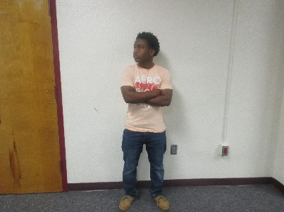
A. I like fishing, going to the beach, quilting, and spending time with my family
Shyheim Riggins

8th grade
Q. What is the best thing about Seminole Middle School?
A. The students, of course!
Q. Is there anything else you would like to say?
A. I love the newspaper that you students put out every month! I am so proud of all the hard work that goes into this publication.
Pg 2

Fashion

Make your fashion statement
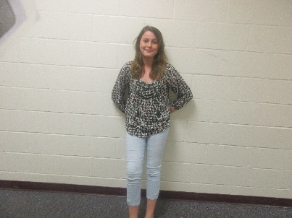
By: Deonna Pritchard and Kylie Sutherland

Q. Why did you chose this outfit?
A. I like the way it looks. It is comfortable and “flowy”.
Q. Who is your inspiration?
A. My older sister because she has good style.
Q. Do you think a brand or logo affects the way you look at clothes?
A. No, because you can have really good clothes that are not a top brand, or you could have a not so known brand with cute clothes.
Q. Who is your inspiration?
A. Myself

Continued on page 5

SMS News

Literary Corner

Haunted
By Savannah Wing

What we know so far: Sierra was warned by her friend Sally to leave the school before something awful happened. Sierra did not listen. But, lately she feels a ghostly presence.
note

Photo By: Serena Regan

Part Three of Haunted

I was doing my normal thing when I got to school. As I approached my locker, I saw a note written in neon pink.
“I’m the one who knows everything about you. I only wish I could have told you sooner.”
The note was all I could think of for the rest of the day. Who could it possibly be? Who knew me so well and also loved me enough to not what to lose me? The only one I could think of is my best friend, Parker. We have known each other since we were been born.

April 2016

The next day I found a buddle of roses in my locker. What could this mean? I thought of talking to a therapist but thought against it instead. Maybe I just have a secret lover.

To be continued . . .

Seminole Events
*a multigenerational
production

Mrs. Dulin’s class at the races
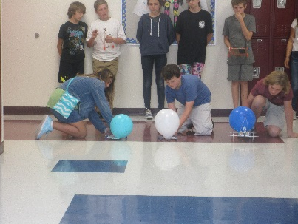
By: Cyrus Karagan
On March fourth, Mrs. Dulin’s seventh period class put their assembled vehicles to the test. These were not normal vehicles; they were balloon powered makeshift cars! A few students were awarded for their cars’ performance. Tressa Fuller representing the Tampa Bay Lightning won the best looking award. Corbin Tesney’s was the quickest, and Brianna Smith’s went the farthest. “Overall, everyone had fun and performed well,” said Mrs. Dulin.
Continued on page 5

Page 3

Theater Review

The Lion King –
A musical worth a roar
*family friendly

By Bruno Boyens

The musical The Lion King, directed by Julie Taymor and with music by Elton John recently came to life at the Straz Center for the performing arts in Tampa. This Broadway Musical has warmed the hearts of millions. This is the 19th anniversary of the show. The show is family friendly. The costumes are amazing. The singing is incredible. My personal favorite song for this production was Be Prepared sung by the villain, Scar. I highly recommend The Lion King.
5 out of 5 thumbs up
See the behind the scenes production by visiting: https://www.youtube.com/watch?v=CccRq08yCr0

SMS News

Game Review
By: Sean Moran and Eddie Pittman

4 out 5 thumbs up
Rated E for everyone

Do you like loud and fast cars and an experience that makes you feel like you are sitting in the driver’s seat of a Ferrari? Forza 6 has 450 high performance autos to choose from. In Forza 6, you are in the position of a professional driver that travels all over the world. For example, one of the twenty-six world-famous locations is a racetrack in the Swiss Alps. If you win that race, you get CR . With that CR, you can upgrade your cars externally and internally. When you get done, you can take photos of your custom beast and share them.

Visit the game trailer at:
http://www.metacritic.com/game/xbox-one/forza-motorsport-6

April 2016

Restaurant Review

Tropical Smoothie Cafe
By: Brianna Frye

5 out of 5
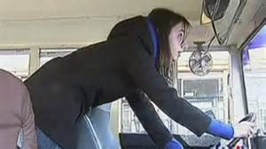
Tropical Smoothie Café uses real, better-for-you ingredients in their smoothies and food which is why you feel better when you eat there. They make super foods taste delicious. Their smoothies are out of this world good. For a tasty treat, try Tropical Smoothie Café – yummy.
Word Scramble
By: Hunter Coon

School

kobo
abkcapck
rdnbie
erpap
atr
tmha
deraign
siecen
ohemowrk
enpilc

Page 4

Teen Heroes

Heart Attack
By: Gavin Williams

Have you ever wondered about what makes a hero? Heroes don’t have to have superpower. Heroes can be a regular teen like Graceann Rumer, a 17 year-old teen from Philadelphia.
What would you do if your bus driver had a heart attack? Rumer knew what to do. She grabbed the steering wheel as the bus driver collapsed from a heart attack. Rumer ran to the bus driver’s seat. The brake was blocked by the bus driver’s foot so she grabbed the wheel and made a U-turn to slow the bus down and change direction as it was heading into oncoming traffic. Then she drove into a ditch. Everyone praised Rumer’s quick thinking and action. But, Rumer dismisses being a hero.
Tell us your teen hero story.

SMS News

Mrs. Dulin’s class at the races
By: Cyrus Karagan

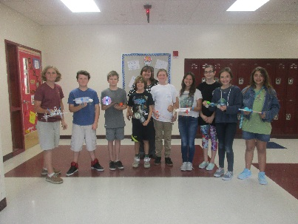
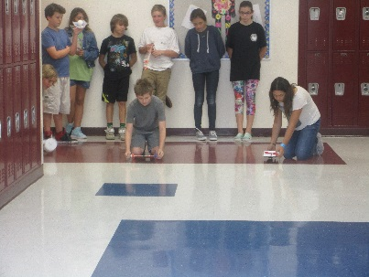
Continued from page 3

Fashion - Continued from page 2

Q. Does a brand or logo affect if you will buy a product?
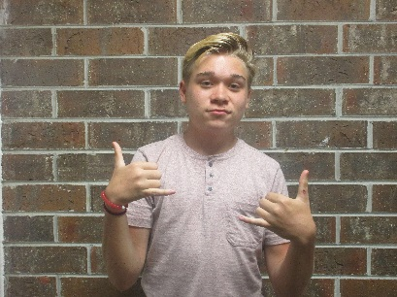
A. Yes, I like certain brands
Payton
Hunter
8th grade

Q. Does a brand or logo affect if you will buy a product?
A. Definitely, because I like wearing name brand products
April 2016

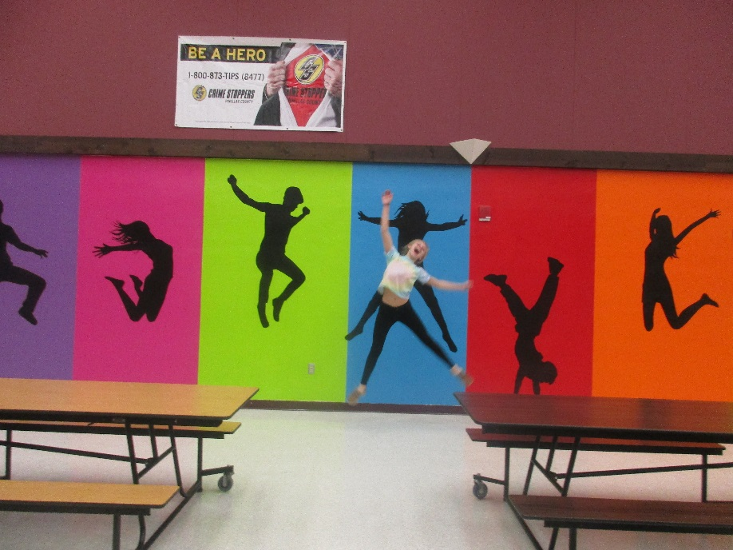
Seminole Middle –
Photo of the month

By: Deonna Pritchard and Kylie Sutherland

Around the world
By Cyrus Karagan

Continued from page one
Where do you think your clothes come from? Probably just a machine, right? Wrong. The story of how the brands you love, such as Nike and H&M, came to a shelf near you is really a sad tale of sacrifice on the part of an unfortunate group who construct our clothes.
A reality TV show by the name of Sweatshop: Dead Cheap Fashion details the struggles of impoverished garment

Page 5

workers in the city of Phnom Penh,
Cambodia from the viewpoints of three young adults who are placed in their situation. One contestant, Anniken, had the original impression that these people had known no better, and that because of this, they aspire to nothing greater. Frida, said this.” I feel sorry for her, but then I think this is how she has lived her whole life….She does not think it is bad.” Although, after her Cambodian experience, Anniken ended with a powerful opinion. “When you talk to a person, you
realize they are just as valuable as you are.”

SMS News

Overall, their thought was this, ”We must influence
and engage people to care.”
When they visited the local factory in Phnom Penh, they discovered just how grueling these people’s jobs were. Ludvig, the third member, said,” Even this place does not have a proper toilet for their workers.”

The workers work 8 to 13 hours a day, while only being allowed one atrocious meal.
The workers were given rice, some green substance which was ridden with worms, and some fish that was rotting and covered in flies.

Workers in these factories are also tasked with sewing non-stop, observed by managers like vultures.

After their encounter, the group was utterly spent and exhausted. After 8 hours of work on a single meal,
they were only paid $3 each.

April 2016

The living conditions the workers are able to afford on their
salary are horrendous. One garment worker, Sokty, had a home as large as a single room that was in total disrepair. Her salary, with extras, was only $130 a month, compared to the average American income of $3,769.

Because of their salary, another worker also said that they are forced to starve themselves, making only a single meal last up to five days.

A garment worker, only 19 years old, told Anniken that her mother had died when she was at an early age. The reason? Not a car crash, not disease, but starvation.

The companies these people work for have immense power, yet they do not act. Protesters, though non-violent, are beaten by police when all they ask for are livable wages and more suitable conditions. Protesters plea, “I beg you who buy Cambodian clothes: help us, we suffer!” Ludvig stated,” The large fashion

Page 6

chains starve their workers, and nobody holds them responsible.” This, surely, must all change.

Protesters will continue the fight until they see change, and we must help.

H&M has launched a plan to better wages and conditions for their workers, but other large chains must be inspired to change.
Ludvig’s final words on the show were these. “The truth is that we are rich because they are poor.”

These workers’ situation is truly unfair, but it will not be altered without effort on the consumers’ end. Perhaps via methods of boycott (with notification to the company of why sales have dropped), or online ridicule and complaint, will motivate these companies to alter their procedures. All in all, only one goal must be reached, and that is that this mistreatment and poverty must stop.

